AWS Lambda
Login to AWS Management Console
Search for “Lambda”
Open AWS Lambda service
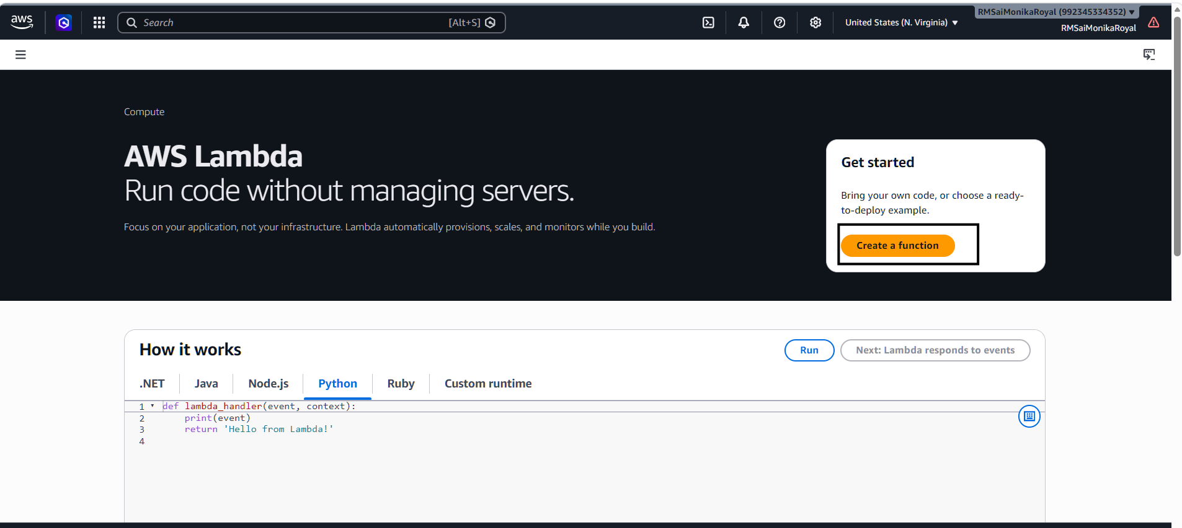
Click “Create Function”
Select “Author from Scratch”
Enter Function Name: my-first-lambda
Runtime: Python 3.x
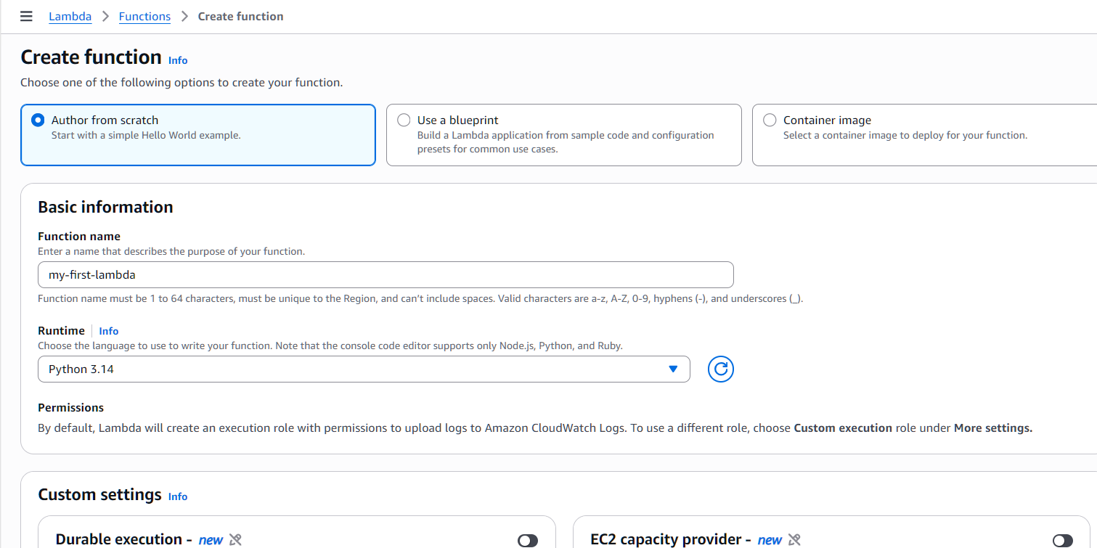

Write Lambda Code >>Click “Deploy”
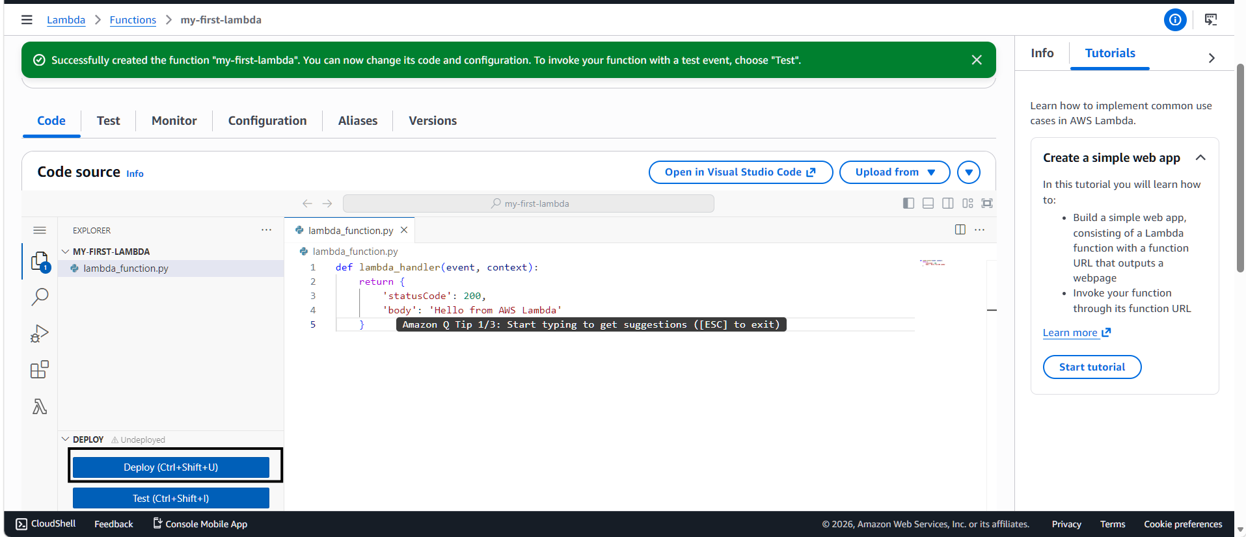
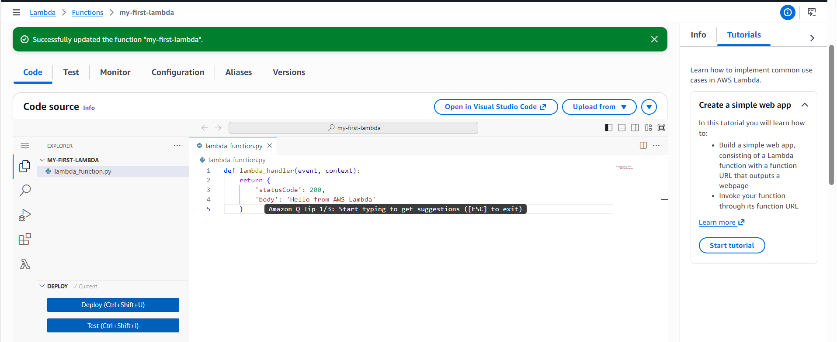
Create test event
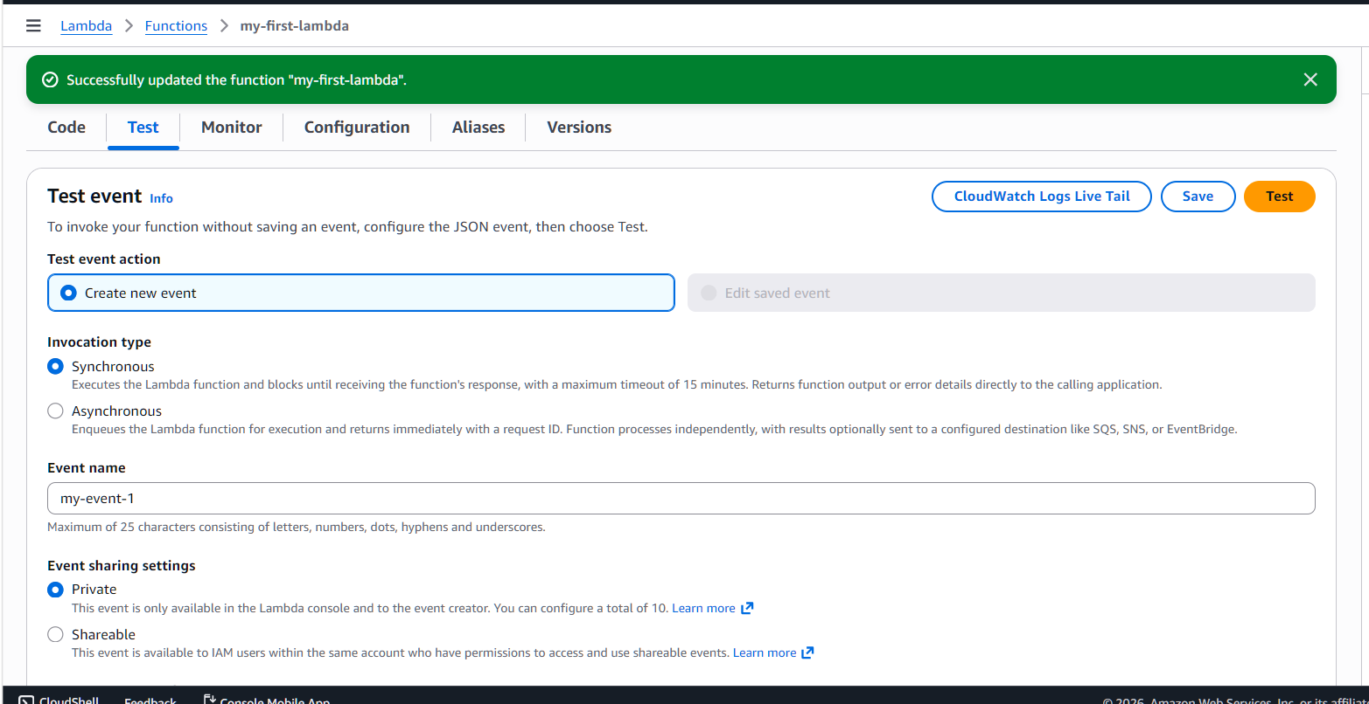
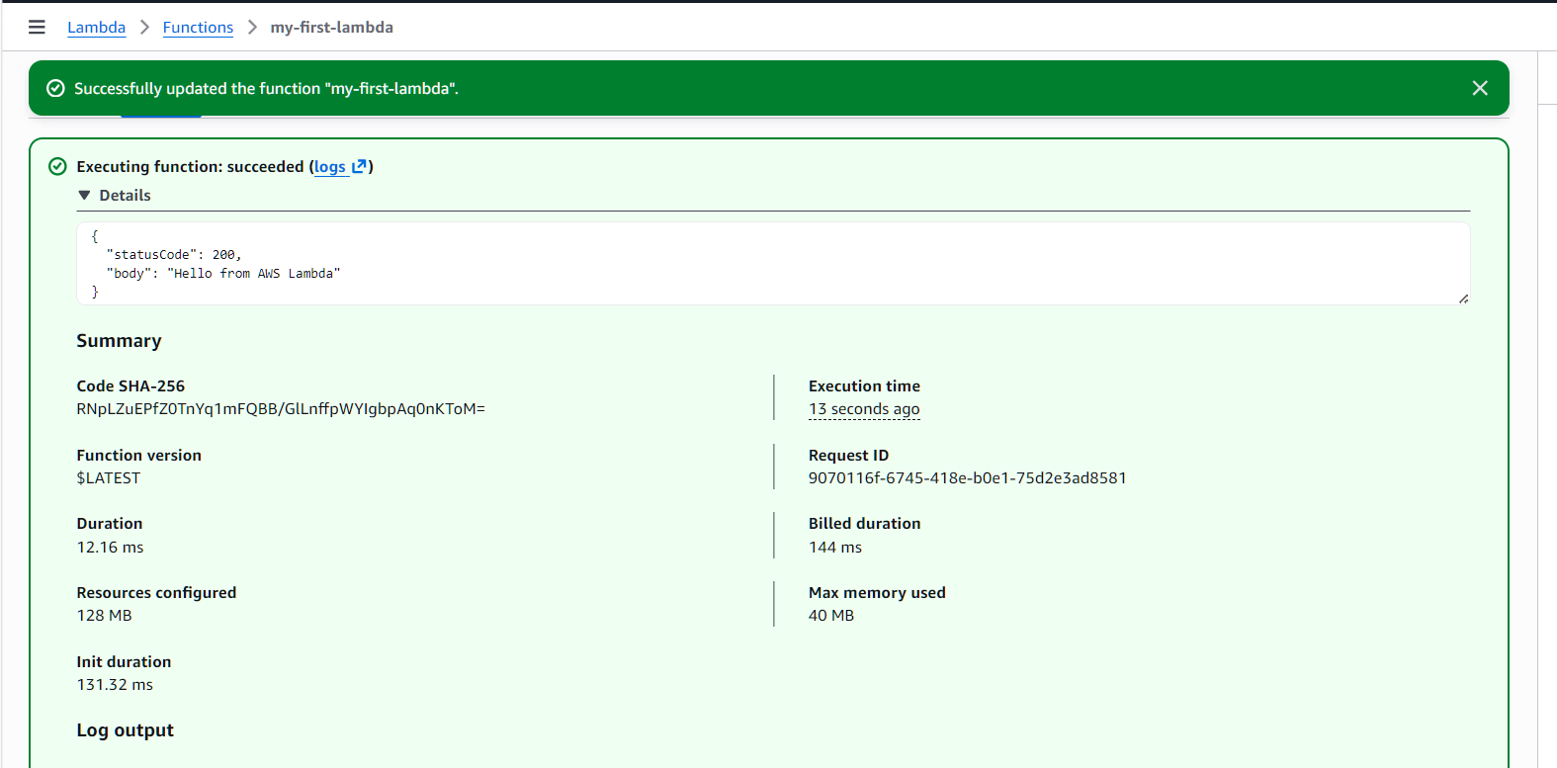
View CloudWatch Logs
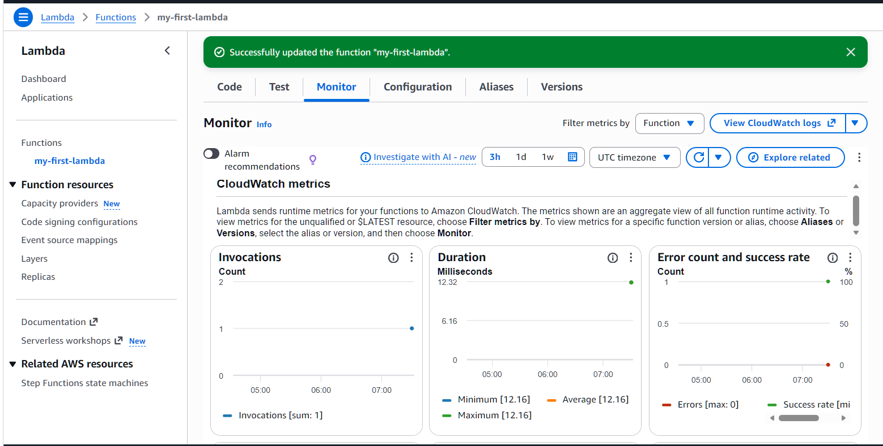
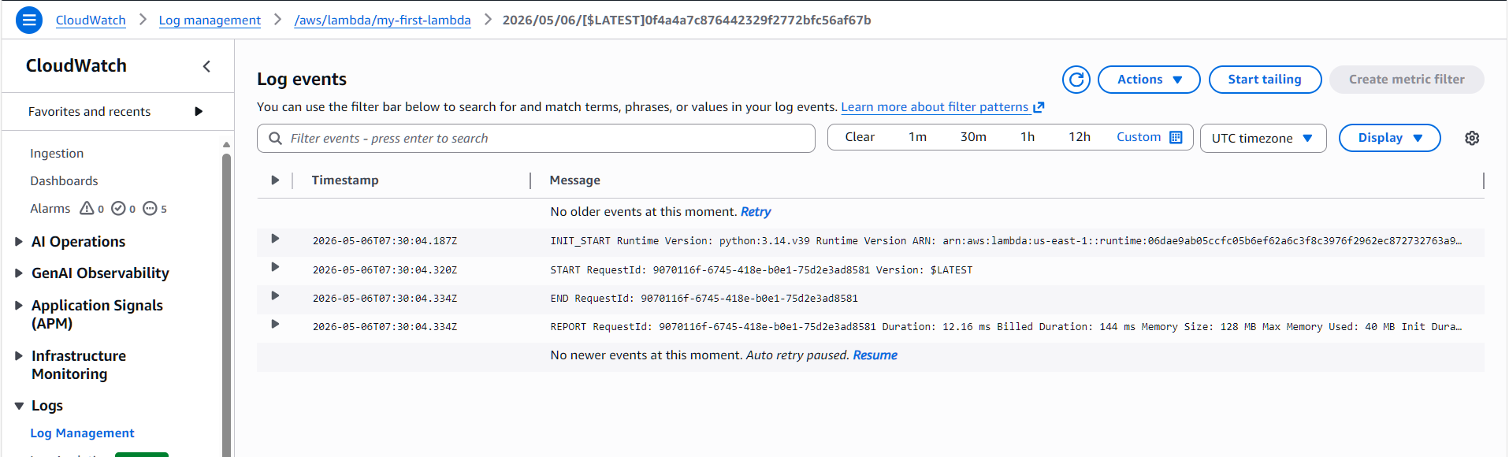

Aim
To create and execute an AWS Lambda function that automatically processes events without managing servers.

Created S3 buckets
And uploaded few files in that
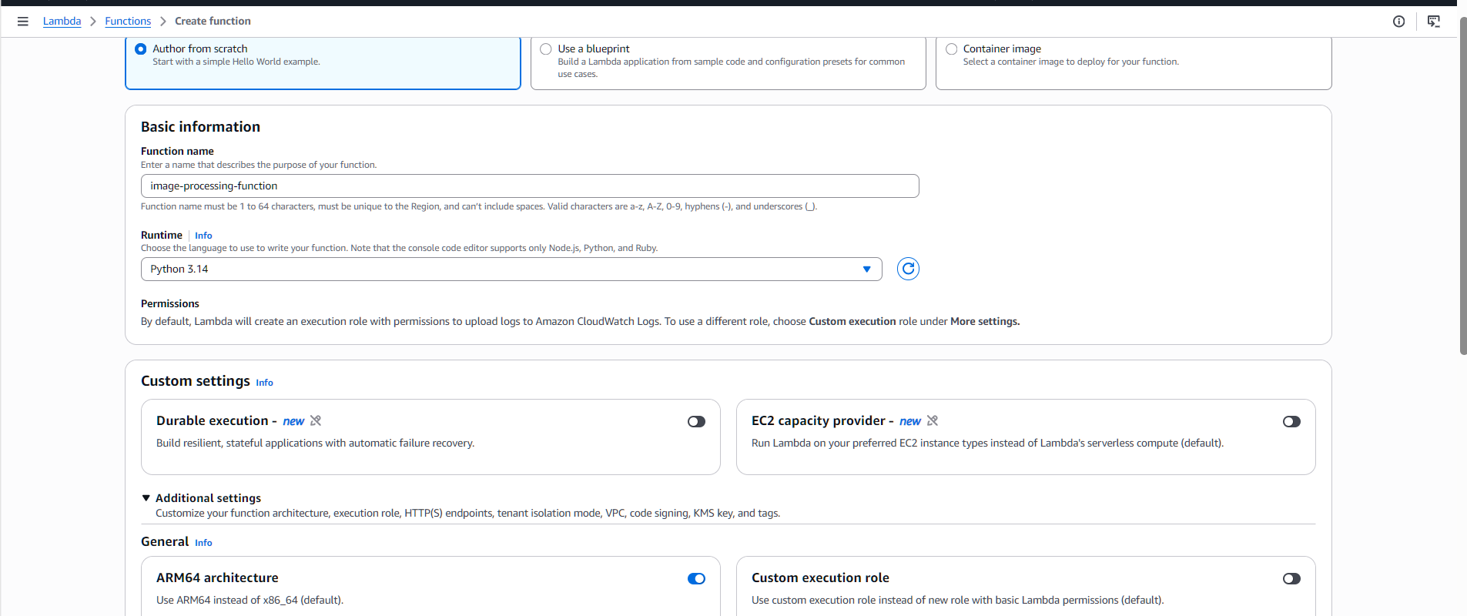
Opened AWS Lambda console and created a new Lambda function.
Selected Python 3.x runtime and x86_64 architecture.
Configured IAM role with basic Lambda permissions.
Attached AmazonS3FullAccess policy to access S3 buckets.
Written Python code inside the Lambda function.
Deployed the Lambda function successfully.
Configured Amazon S3 as the trigger source.
Selected PUT (Object Created) event type for automatic triggering.
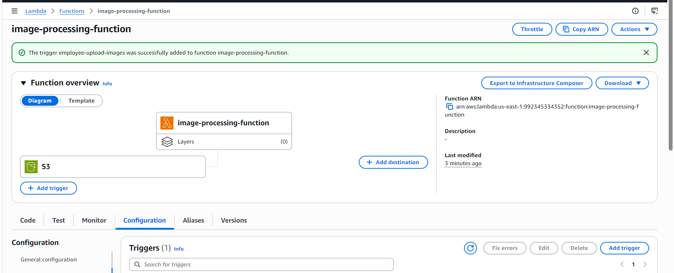
Uploaded a file into the S3 input bucket.
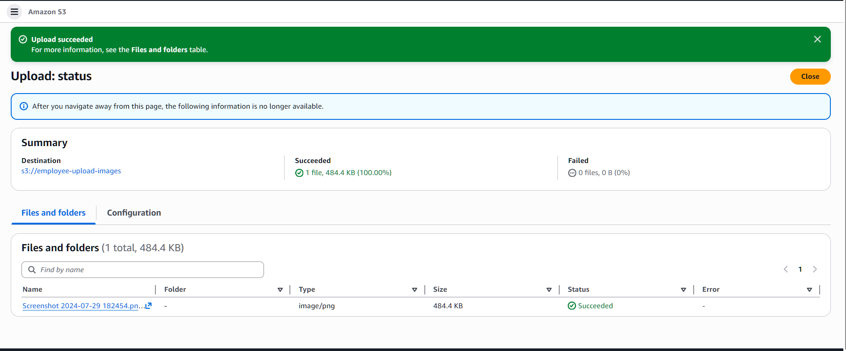
Lambda function triggered automatically after file upload.
Verified execution logs using CloudWatch Logs.
